SCHOOL DISTRICT NO. 38 (RICHMOND)

MAPLE LANE ELEMENTARY SCHOOL
7671 Alouette Drive, Richmond, BC V7A 4P2
Phone: (604) 668-6692. Fax: (604) 668-6694
Mrs. Lisa Schwartz , Principal

Maple Lane Community
The Week Ahead May 1st -May 5th, 2023
MONDAY: Wali Shah performance for grade 4-7 @ 9:00 a.m.

TUESDAY: McCreary Study for Grade 7 students only (notice sent home last week)

WEDNESDAY: Track and Field Information Assembly for students @ 2:15
Monthly PAC Meeting @ 6:00 pm
Meeting Link https://teams.live.com/meet/9342372602396

THURSDAY: Zone Track Meet @ Minoru

FRIDAY: Whole School Field trip: Shrek the Musical @ South Delta Secondary

FRIDAY:
Monday:

Tuesday:

Wednesday:

Thursday:

Friday:

Student Placements (Organizing Classes for 2023-2024)
In the spring of each year schools begin their planning for the coming fall. We have preliminary staffing meetings with school board office personnel and review possible scenarios for organization in the Fall. The school population fluctuates as students continue to move into the area, and some students transfer out. The final school organization and class placements occur the first week of school in September.

During this time, the professional staff at Maple Lane begin to gather and share information in preparation for student placement in September. We are restricted by grades that are assigned to divisions (based on student numbers), and at times there are few options. We do however devote time, care, and effort in determining September placement. We include information about student strengths and needs, their social relationships (we try to ensure they have at least one friend), their interests, their learning styles, and previous placements.

Parental Input
Students are placed into classes in consultation with classroom teachers, learning resource teachers and the principal. Should parents wish to describe the learning situation and environment they feel best suits their children, or other factors which might influence placement, we ask that a letter be directed to Mrs. Schwartz (lschwartz@sd38.bc.ca) by Friday, June 2nd, 2023. The information you provide should not include a request for a specific teacher, but rather some important personal or educational information that will assist us in our decision. All letters regarding placement are shared with teaching staff.

Minoru Track Meet
If your child is attending the track meet at Minoru on Thursday and you have been unable to arrange a ride back to the school at the end of the track meet, please talk to your child’s classroom teacher or email Mrs. Schwartz directly, lschwartz@sd38.bc.ca

Talent Show
Our annual talent show was a huge success. It is wonderful to see the many talents on display by our students. Thank you to Mrs. Hung and Ms. Lau for helping with the organization of music and the practices. Thank you to the staff for working together to create another fantastic staff talent.

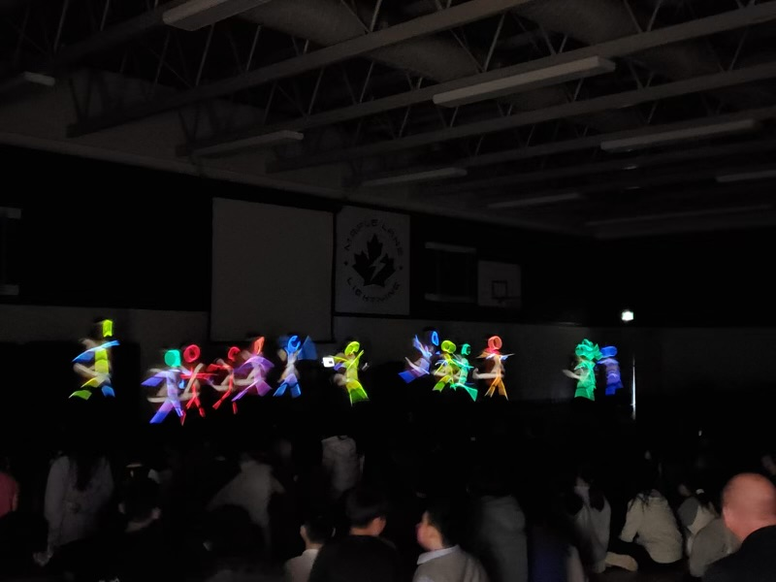

Parking Lot Access Week of May 1st
The parking lot update continues. Paving will happen next week. Thank you for your continued patience and flexibility as we work to improve traffic flow in our west parking lot.

Shrek the Musical
All classes will attend the Delta Youth Theatre’s performance of Shrek the Musical on Friday, May 5th. A big thank you to our PAC who paid for the transportation to and from the field trip. This is just one of the ways that the PAC uses the money they raise on fundraising initiatives to support students and staff at Maple Lane.

Summer Learning
Attention Richmond families! Did you know that many of Richmond Continuing Education Summer Learning Programs are FREE for BC students who are Canadian Citizens, Permanent Residents and students who have Refugee status? With an array of exciting and enriching courses and camps to choose from, your child is sure to have a memorable summer. Choose from Elementary Enrichment, Summer Exploration, Summer Fine Arts, Academic Full Credit, Academic Completion, Secondary Enrichment, and Secondary Enrichment Skill Building Courses. We also offer Summer Camps for both elementary and secondary students, with options for ages 6-16. Don't miss out on this opportunity to grow and learn in a fun and engaging way! Keep your child's learning journey going strong this summer and sign up now for Summer Learning 2023.
For more information click here www.RichmondCE.ca

PAC CORNER

Spring Fling and Silent Auction
The Maple Lane Spring Fling Carnival is just a few weeks away, and we need your help!

As our largest event of the year, it takes an incredible amount of planning and support to pull off a successful event. This year, we are so thankful that our grade 6/7 leadership team has offered to help volunteer during the event. In addition to this team, staff, and our PAC Committee, we are in need of parent/caregiver volunteers on the evening of the event - Thurs, May 18th.

Tasks range from 50/50, to assisting with carnival games, silent auction, and other activities offered at the Spring Fling. We have put together a volunteer sign-up, and have divided the shifts in half so that if you are volunteering you still will be able to enjoy a large portion of the event with your families.

Please see the link below for sign-up details.

https://www.signupgenius.com/go/60B0A48A5AD28A4FE3-maple

What’s Happening at Maple Lane
May 11th- SLSS Grade 7 Fun Day
May 12th- Spirit Day- 80’s Day
May 12th- Hot Lunch Day- Pizza
May 17th- Welcome to Kindergarten
May 18th- PAC Sponsored Spring Fling
May 19th- Professional Development Day- No School for Students
May 22nd- Victoria Day- No School
May 23rd- Saleema Noon Parent Information Session @ 6:30
May 24th- Saleema Noon Student Sessions
May 26th- Division 1 and 2 Expo
June 2nd- Core French Cultural Experience- Sand the Circus Leader (grade 4-7)
June 2nd- Hot Lunch Day (Pizza)
June 5th- K, 1, 6 and 7 Immunizations
June 8th- Shayna Jones Story Telling Presentation (Popping Toads and Lion Skins)
June 9th- Sports Day and Hot Lunch Day (Subway)
June 16th- Whole School Field Trip: Swimming at South Arm (9:30 am & 11:30 am)
June 21st- National Indigenous Day
June 23rd- Recognition Assembly
June 26th- Whole School Field Trip: Spanish Banks
June 27th- Term 3 Learning Update posted to MyEd
June 28th- Grade 7s to Victoria
June 29th Last day for students and Grade 7 Farewell
June 30th- Admin Day

