SCHOOL DISTRICT NO. 38 (RICHMOND)

MAPLE LANE ELEMENTARY SCHOOL
7671 Alouette Drive, Richmond, BC V7A 4P2
Phone: (604) 668-6692. Fax: (604) 668-6694
Mrs. Lisa Schwartz , Principal

Maple Lane Community
The Week Ahead Feb. 6th -Feb 10th, 2023
MONDAY:

TUESDAY: PAC Meeting @ 7:00 p.m. (Virtual on Teams)

WEDNESDAY:

THURSDAY Girls Basketball vs Whiteside (Home)
Boys basketball vs Whiteside (Away)

FRIDAY: PAC Hot Lunch Day- Pizza

FRIDAY:
Monday:

Tuesday:

Wednesday:

Thursday:

Friday:

Student and Family Affordability Fund
The Student and Family Affordability Fund is designed to assist families
who require financial assistance with school-related costs in the following areas:
· school and course fees
· school supplies and course materials
· field trips
· school-related extracurricular opportunities
· clothing and footwear required for sports and school activities
The additional funding is also used to support school meal programs and other nutritional supports for students.
Please reach out to Mrs. Schwartz, if you are in need of assistance. As always, all requests will be treated with dignity and your privacy will be respected.
We want to work with our families to ensure that our students, your children, have everything they need in order to be successful at school. Please do not hesitate to reach out if we can help.

Learning Opportunity Unlearn: Critical Thinking by Design
Unlearn founder Abhi Ahluwalia, is coming to Richmond in February for 2 repeat Pro-D sessions for all district staff. In addition, we will be offering an evening webinar for parents and staff by Unlearn. The focus of these sessions is to challenge participants to think critically about bias, stereotypes, prejudice, and discrimination. Participants will be lead through experiential activities designed to raise equity consciousness and highlight the bias we all have and to better understand how we can use this awareness to create a safe, caring, and inclusive environment promoting dignity and respect for all.
February 16, 2023- UnLearn-Parent/Community Webinar
February 17, 2023 – UnLearn- Teacher Workshops

Week of February 13th-Parking Lot Disruption
The modular building that will house the Ministry of Education childcare will be arriving the week of February 13th. The west parking lot will be unavailable during this time.
To ensure the safety of all students, please do not leave your vehicle unattended in the drop off lane to bring your child into the school or pick up at the end of the day.

Session for Parents
SWIS (Settlement Workers In Schools) have organized a session for parents titled, "Tips for Successful Students" on Wednesday, Feb 08 at 10 a.m. Please click the attached poster for more information and how to register.

A Reminder: Please report lates and absences to our Early Warning Phone Number at 604-668-6192

PAC CORNER
The deadline for ordering hot lunch for next week’s Hot Lunch day is today at 11:59 pm.
Below are upcoming PAC Hot Lunches and ordering deadlines
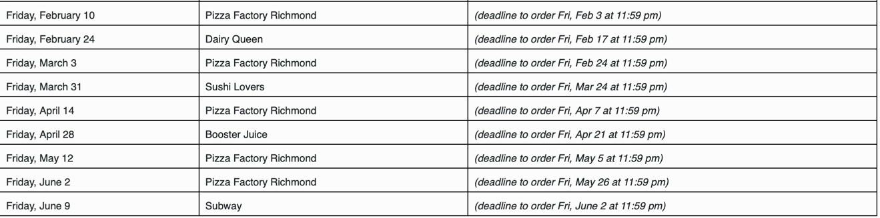
All PAC news can be found by clicking here

Upcoming Dates
February 13th-16th- Scholastic Book Fair
February 15th and 16th- Early Dismissal @ 1:45 for Student Conferences
February 17th- Pro D Day
February 20th- Family Day- No School
February 21st – Girls Basketball vs Errington (Home Game)
February 22- Pink Shirt Day
February 22nd- Boys basketball vs Garden City (Home Game)
February 23rd – Girls’ Basketball vs Wowk (Home game)
Feb. 24th- Matching Day (also called duplicate day or twin day)
February 24th- PAC Hot Lunch Day- Dairy Queen
February 28th- Seadome
March 3rd- PAC Hot Lunch Day- Pizza
Mar. 3rd- Jersey Day (this includes Maple Lane spirit wear)
March 1st-3rd- SLSS Grade 7 basketball tournament
March 6th-10th- Richmond Martial Arts Lessons (K-7)
March 8th- Report Cards posted to MyEd Parent Portal
Mar. 10th- Colour Day
March 10th- Last Day Before Spring Break

