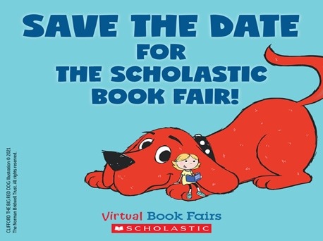

Scholastic Book Fair is Coming!

Dear families,

The Maple Lane Library is hosting an in-person Scholastic Book Fair from
February 13th - February 16th, 2023. Students will get to visit the Scholastic book fair during their library blocks and make purchases in-person at lunch and after-school.

The Scholastic Book Fair is a fantastic way to continue to give our students access to the books they want to read. We’re excited that you will be able to shop
together, selecting the books that inspire your readers!

All purchases benefit our school and earn Rewards that can be redeemed for books and Education Resources for our school’s classrooms and library.

You can preview some of the books that will be available at the fair by visiting the link below:

https://digital.scholastic.ca/sites/bookfairs/featured-books/

Happy reading!

Mrs. Sandhu
Teacher-Librarian at Maple Lane

