SCHOOL DISTRICT NO. 38 (RICHMOND)

MAPLE LANE ELEMENTARY SCHOOL
7671 Alouette Drive, Richmond, BC V7A 4P2
Phone: (604) 668-6692. Fax: (604) 668-6694
Mrs. Lisa Schwartz , Principal

Maple Lane Community
The Week Ahead Jan. 9th -Jan. 13th, 2023
MONDAY:

TUESDAY: PAC Meeting at 6:00 pm on Teams

WEDNESDAY: Snowshoeing at Mount Seymour (Div. 3, 4, 5, 6)

THURSDAY: Camp Jubilee Parent Information Night @ 7:00 pm

FRIDAY: Black Excellence Day

FRIDAY:
Monday:

Tuesday:

Wednesday:

Thursday:

Friday:

Welcome back everyone. It has been wonderful to re-connect with everyone and hear stories of family time, outside time and other ways that families made memories over the break.

Black Excellence Day
Black Excellence Day started from the movement of Black Shirt Day in early 2021. In consultation with various community members including the Centre of Israel and Jewish Affairs, the term “Black Shirt” was identified as causing harm and trauma for survivors of the Holocaust. Recognizing this, the movement Black Excellence Day was created in its place. This day is an opportunity for students and staff to learn about the contributions of Black Canadians, and their ongoing civil rights struggle. The term “Black Excellence” was born out of the civil rights movement in the 1960’s and honours great civil rights leader, Dr. Martin Luther King Jr. who was born on January 15, 1929.

For Grade 6/7 Families- Reminder of Camp Jubilee Information Evening
This will be an in-person meeting at Maple Lane in the library at 7:00 p.m. A Camp Jubilee Camp Counsellor will be here to go through a presentation and answer any questions you have.

PAC Meeting
Our January PAC meeting will be Tuesday, January 10th at 6:00 p.m. via Teams. The November meeting minutes are attached and the link will be sent out to all families next week.

PAC Hot Lunch Days
Please see the attached flyer for PAC Hot Lunch days for the rest of the school year. Ordering is now opening via Muncha Lunch.

Here are the dates and deadlines for ordering Hot Lunch day:
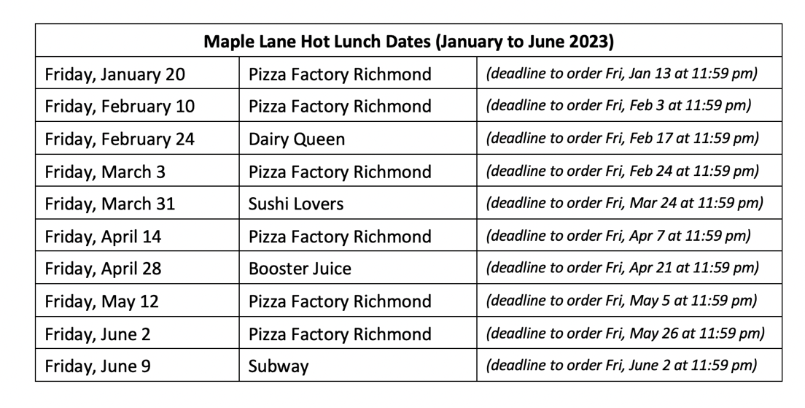

PAC CORNER
All PAC news can be found by clicking here

Upcoming Dates
January 16th- Division 7 and 10 Ice Skating at Minoru 10:30-12:30
January 18th- Kindergarten Screening (Hearing & Dental) 9:00 a.m.
January 18th- Steveston London Counsellor Visit for our Grade 7 students
January 20th- Hot Lunch Day- Pizza
Jan. 23-27th- Breaking and Hip Hop Lessons in the gym (K-7)
January 25th- Steveston London Parent Information Evening @ 7:00 p.m. @ SLSS
January 27th – Hip Hop Performance for Families @ 2:00 pm
January 30th- Pro D Day- No School for Students
January 31st- In School Field Trip: Division 10- Science Workshop 1:00-2:45 pm
February 1st- Global Play Day
February 10th- PAC Hot Lunch Day- Pizza
February 13th-16th- Scholastic Book Fair
February 15th and 16th- Early Dismissal @ 1:45 for Student Conferences
February 17th- Pro D Day
February 20th- Family Day- No School
February 22- Pink Shirt Day
February 24th- PAC Hot Lunch Day- Dairy Queen
February 28th- Seadome
March 3rd- PAC Hot Lunch Day- Pizza
March 6th-10th- Richmond Martial Arts Lessons (K-7)
March 8th- Report Cards posted to MyEd Parent Portal
March 10th- Last Day Before Spring Break

