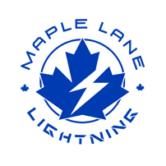
SCHOOL DISTRICT NO. 38 (RICHMOND)

MAPLE LANE ELEMENTARY SCHOOL
7671 Alouette Drive, Richmond, BC V7A 4P2
Phone: (604) 668-6692. Fax: (604) 668-6694
Mrs. Lisa Schwartz , Principal

Maple Lane Community
The Week Ahead Nov. 28th-Dec. 2nd, 2022
MONDAY:

TUESDAY:

WEDNESDAY: Grade 7 Volleyball Tournament at Richmond High

THURSDAY: Immunizations (Grade 6/7) @ 9:00 a.m.
Field Trip: Capilano River (Salmon)- Div. 7, 8 and 9

FRIDAY: Field Trip: Delta Youth Theatre Production of Newsies- Division 1-6

FRIDAY:
Monday:

Tuesday:

Wednesday:

Thursday:

Friday:

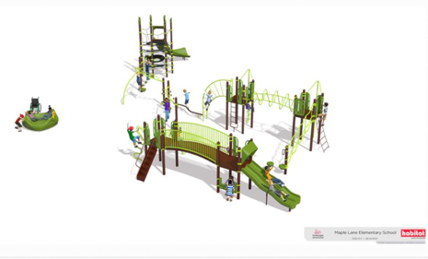
Community Installation This Weekend
We are excited for our community installation project happening this weekend from 8:00-4:00. This project will go ahead rain or shine. Thank you to everyone who has volunteered their time. A big thank you to the PAC for organizing the event.
MyEd Parent Portal
At Maple Lane Elementary we are continuing to use the MyEd parent portal to help our families access your child’s school information directly online. MyEducation BC PARENT PORTAL has been initiated. This parent portal allows parents and/or guardians to access attendance, term grades, report cards and other information on their child(ren). Instructions on how to set up your account can be found on our school website. Here is a link: https://maplelane.sd38.bc.ca/news/2022/11/myed-bc-parent-portal-access

Upcoming Spirit Days
We are looking forward to some spirit days in December.
December 9th- Fun Hair or Hat Day
December 16th- Pajama/ Comfy Cozy Day

PAC CORNER
All PAC news can be found by clicking here

Winter Wonderland-Family Skate
Come join us at the Winter Wonderland at Minoru Arenas on Saturday, December 10th from 4:30-6:00 p.m. Set under a canopy of twinkly lights with festive music, we invite you to join us for this family-friendly winter time activity!

This event is open to all Maple Lane families - students, siblings, parents/caregivers and staff, and is for all ages and abilities.

Please note, all children must be accompanied by an adult/caregiver who has purchased a ticket (skating or not).

For those just learning to skate, on-ice stabilizing devices will be available. Strollers (with harnesses) are also permitted for babies and young children.
The City of Richmond recommends wearing a CSA approved hockey helmet to prevent injuries. Helmets will be available for use at no charge.
Click here to buy tickets.

Upcoming Dates
December 8th- Late French Immersion Presentation for Grade 5 students @ 9:00
December 9th- Hot Lunch- Pizza
December 9th- Spirit Day: Fun Hair or Hat Day
December 10th- PAC Event- Winter Wonderland Family Skate 4:30-6:00 p.m.
December 14th- Winter Concert @ 1:00 pm
December 15th- December PAC Meeting
December 16th- Spirit Day: Pajama Day/Comfy Cozy Day
Last day before Winter Break

