Maple Lane Elementary School
SCHOOL DISTRICT No. 38 (RICHMOND)
7671 Alouette Drive, Richmond, BC V7A 4P2
Tel: (604) 668-6692 Fax: (604) 668-6694
Website: https://maplelane.sd38.bc.ca/

Mrs. L Schwartz
Principal

The Week Ahead: June 6th – June 10th, 2022
Monday
Tuesday | PAC Annual General Meeting @ 6 pm
Wednesday
Thursday | Division 1 & 2 Oval Field Trip
Friday
INFORMATION ITEMS
Notice of Late Return If your child will be returning late to school in September; LATER THAN 12:00 pm Wednesday, Sept. 7, 2022 AND ON or BEFORE Sept. 14, 2022 please be sure to complete and submit the Notice of Late Return Form that was sent home earlier this week. If you need a copy of this form, please contact the school office at 604.668.6692. Thank you!
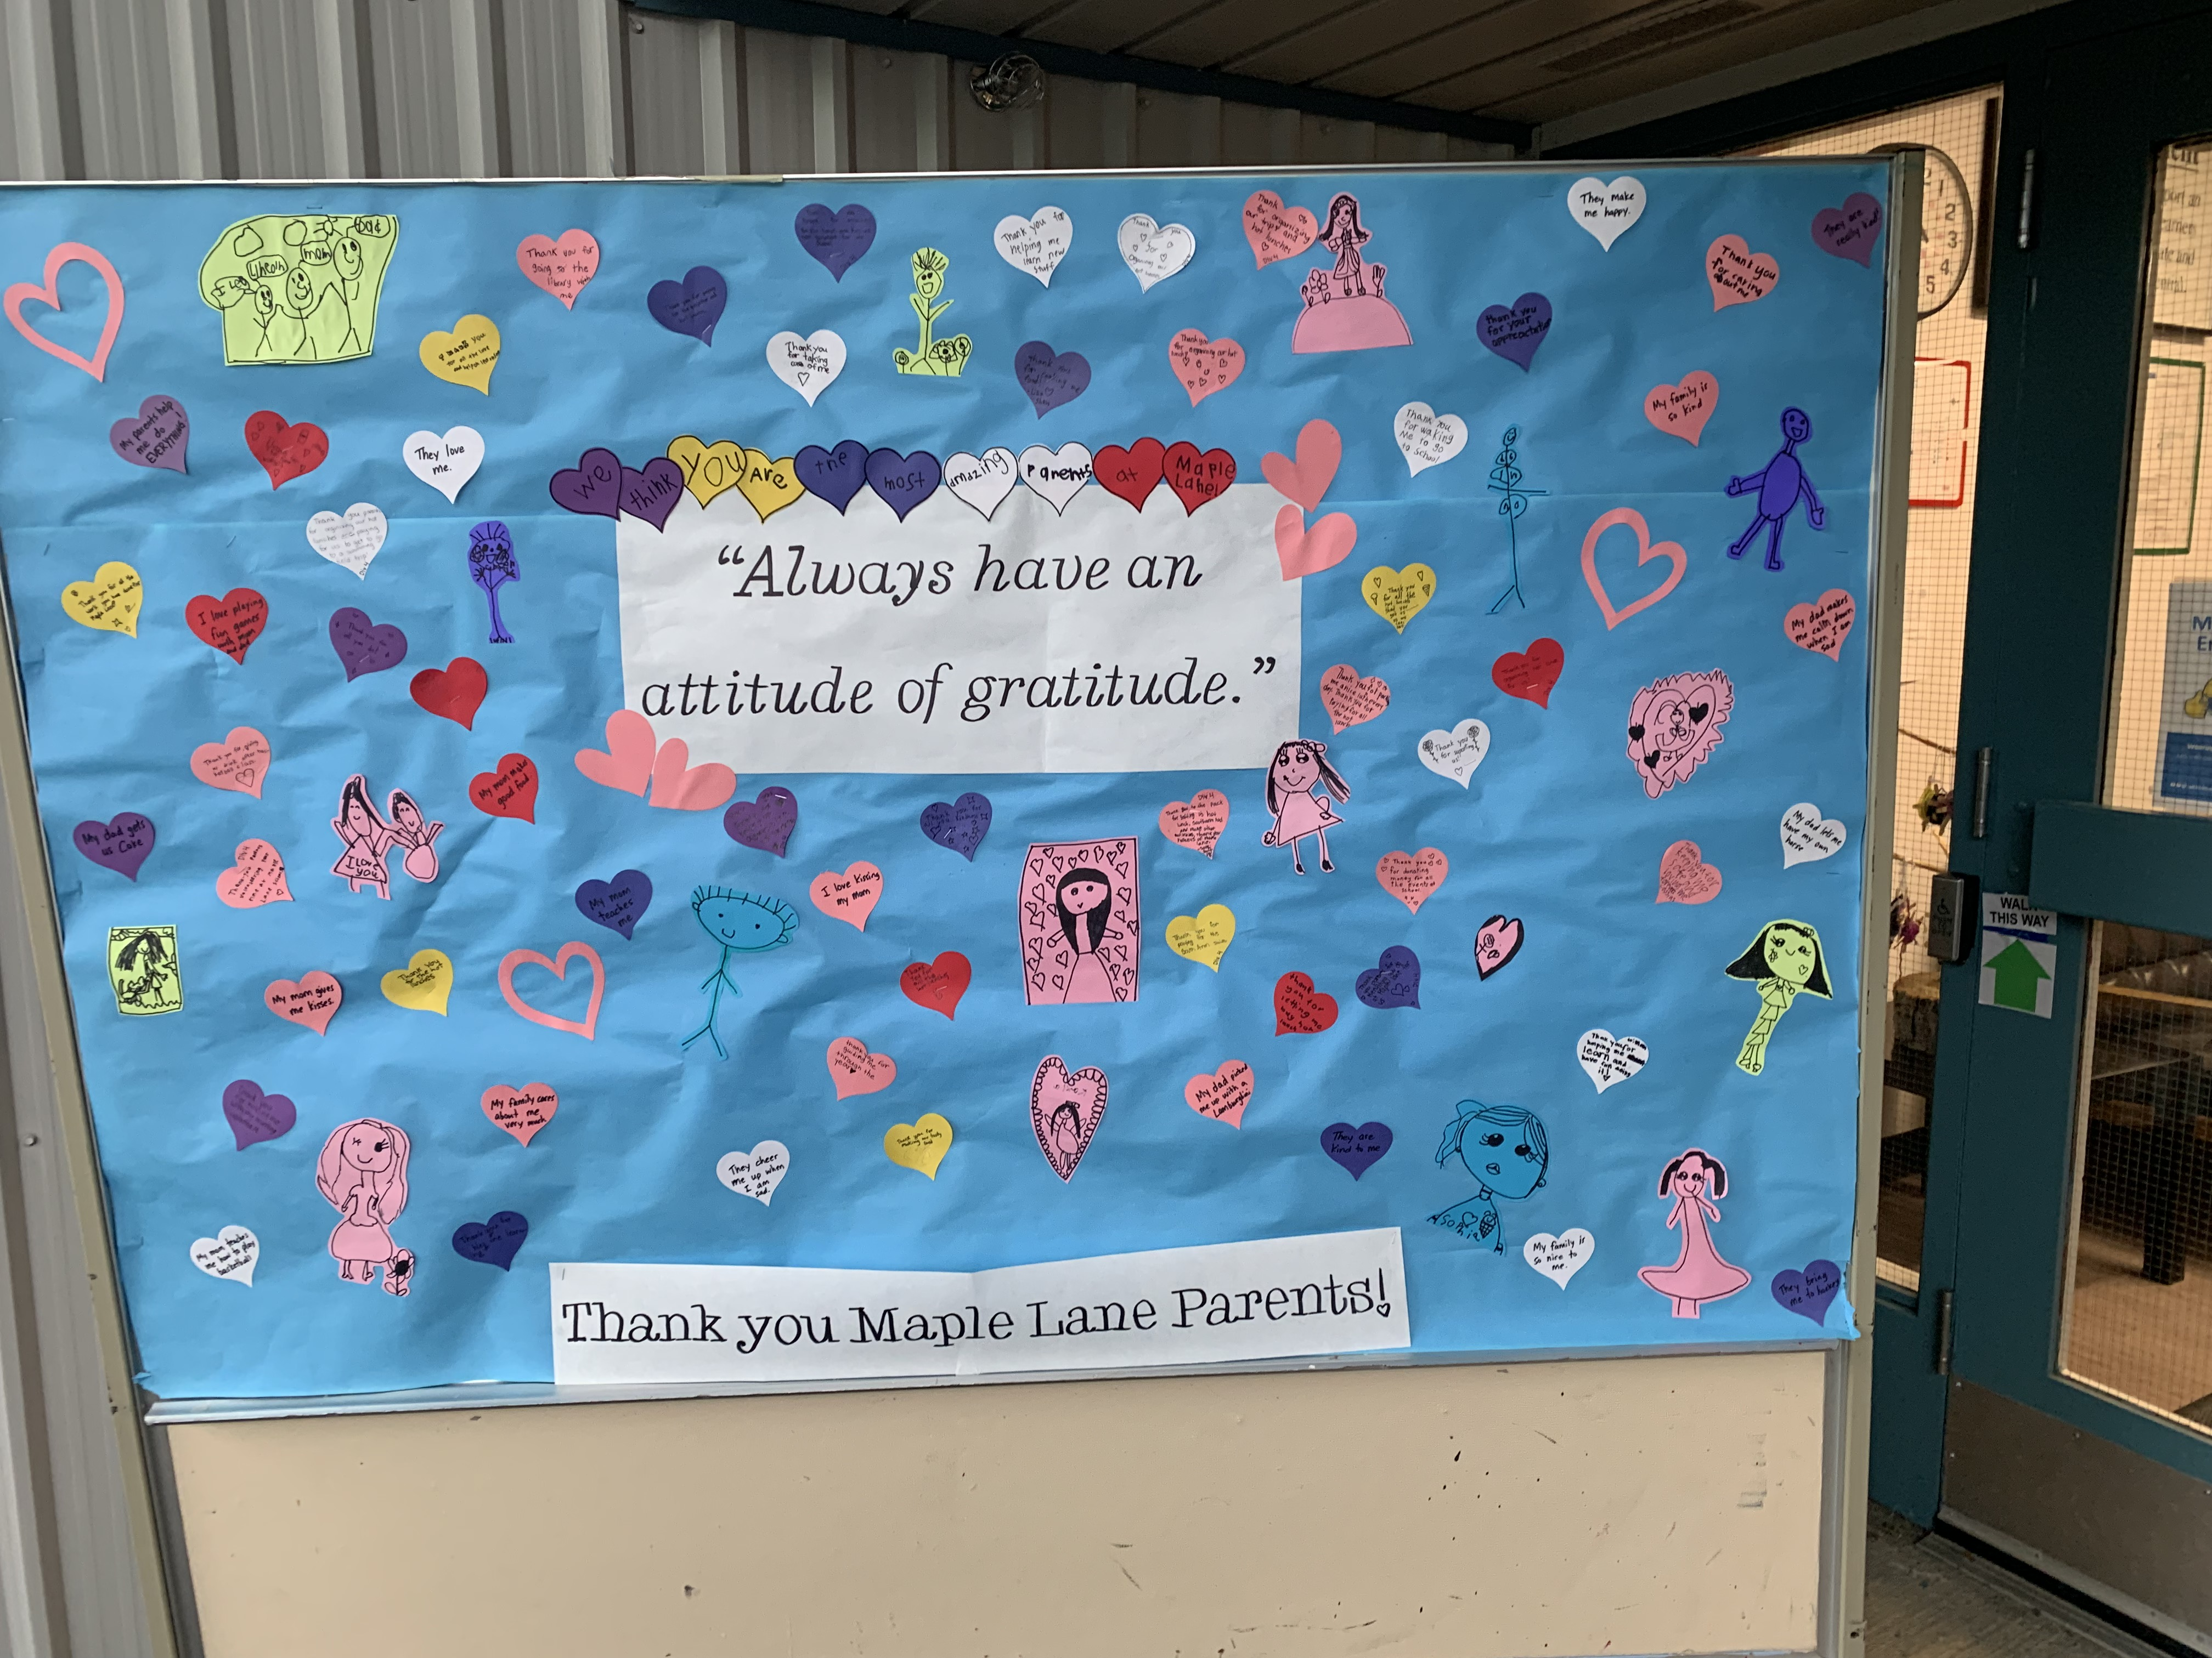
Gratitude for Families It is hard to believe we are in the final month of this school year. Today at Sports Day we took this opportunity to say a big thank you to parents, guardians and other adults who support our Maple Lane children. From the parent volunteers on our PAC committee, to our hot lunch volunteers to all that you do day in and day out to get your children to school. We thank you!

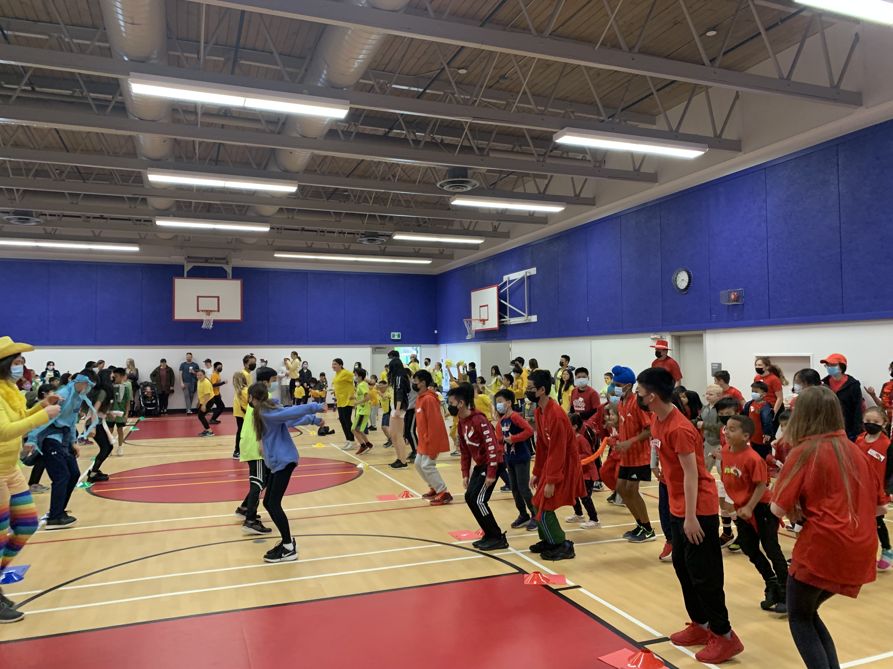
Indoor Sports Day It was a great day. The staff were amazing in pivoting on short notice and adapting their stations for indoors. The student leaders did a fantastic job supporting students and leading by example.

PAC CORNER
Reminder of PAC Annual General Meeting:
The Maple Lane PAC Annual General Meeting will be Tuesday, June 7 at 6:00 pm on Teams. The link is below. Dave Warner from Habitat will be joining us for the first ten minutes of the meeting to review three playground proposals.
You're invited to join a Microsoft Teams meeting
Title: Maple Lane Elementary PAC - AGM 2021-2022
Time: June 7, 2022 6:00:00 p.m. Pacific Daylight Time
Join on your computer or mobile app
Click here to join the meeting
IMPORTANT DATES and UPCOMING EVENTS
June 17th- South Arm Swimming. 11-12 (Div. 1,2, 7, 8, 9) and 1-2 (Div. 3, 4, 5, 6, 10)
June 21- National Indigenous Day
June 22nd- Band Concert @ 2:00 pm and 6:00 pm
June 23rd- Recognition Assembly (time to be determined)
June 27th- Report Cards Go home (all Divisions)
June 28th- DARE Grad for grade 4s and 5s 10:30-12:00
June 28th- Grade 7s to Victoria
June 29th- Grade 7 Farwell Assembly @ 10:30 a.m.
June 29th- Last day of classes for students (8:45-2:45)

