Maple Lane Elementary School
SCHOOL DISTRICT No. 38 (RICHMOND)
7671 Alouette Drive, Richmond, BC V7A 4P2
Tel: (604) 668-6692 Fax: (604) 668-6694
Website: https://maplelane.sd38.bc.ca/

Mrs. L Schwartz
Principal

The Week Ahead: May 23rd – May 27th, 2022
Monday | Victoria Day- No School
Tuesday
Wednesday | Welcome to Kindergarten (1:15-2:30)
Thursday | Camp Store @ 12:20 in the multi
Friday | Division 1 and 2 Expo
INFORMATION ITEMS
Save the Date (Band Concert): Grade 6 and 7 families, please mark your calendars. On June 22, 2022, band students will be sharing their learning with two band concerts. At 2:00 p.m. Grade 6 and 7 students will play for Maple Lane staff and students and at 6:00 p.m. they will play for families. Thank you, Ms. Lam, for guiding our students this year and planning this concert.

Save the Date (South Arm Pool): Swimming at South Arm is a beloved year end tradition at Maple Lane. We are happy to share with you that we have secured a date for swimming at South Arm. On Friday, June 17th from 11:00-12:00 (Division 1, 2, 7, 8 and 9) and 1:00-2:00 (Division 3, 4, 5, 6 and 10). A field trip notice will go home closer to the date with more information and a request for parent volunteers. Thank you to the PAC for sponsoring this fun event.
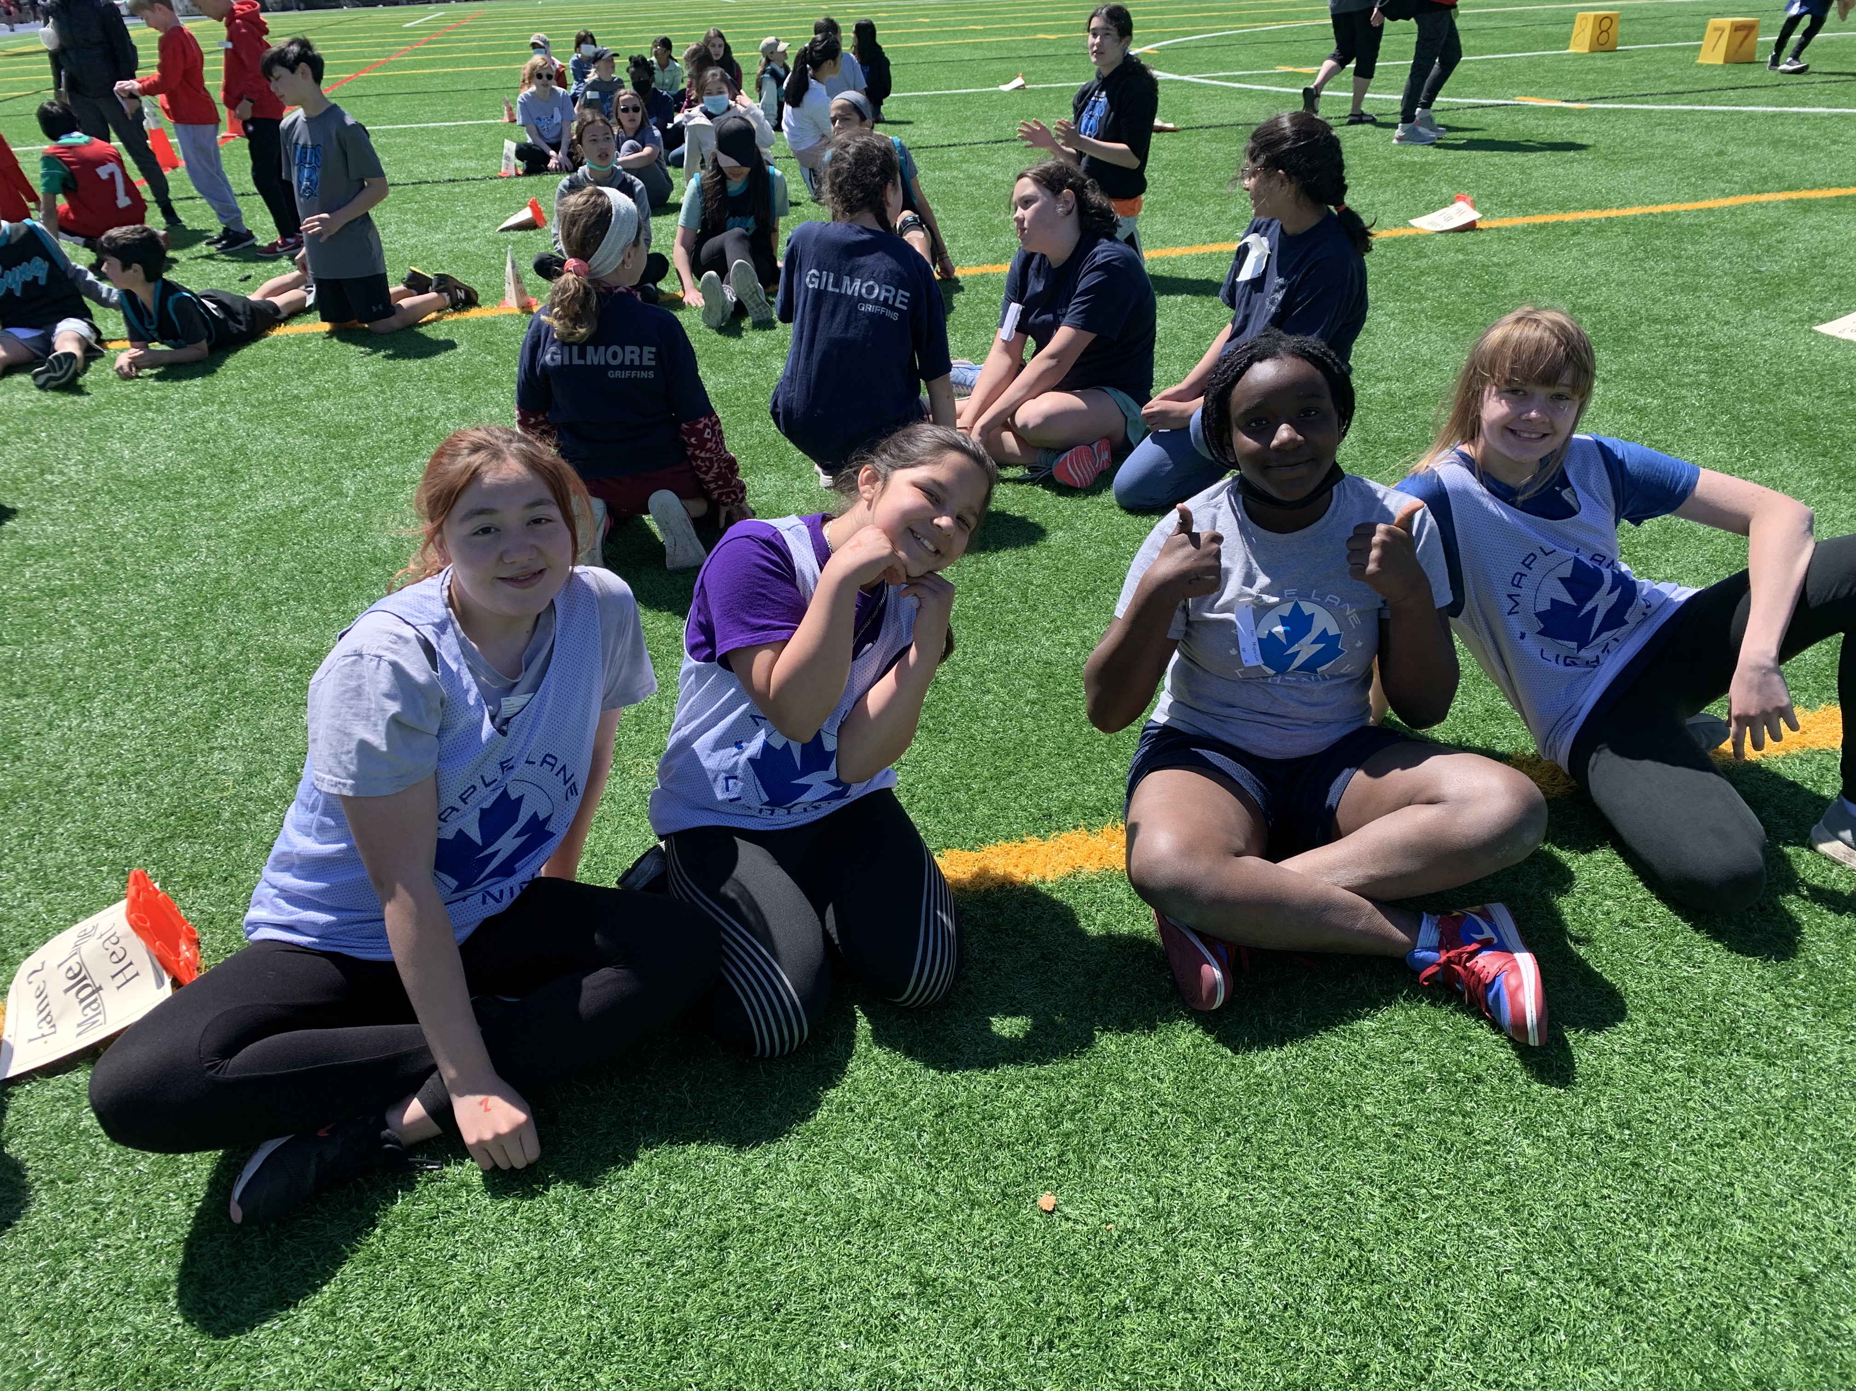
Track Meet: Congratulations! Our Zone Track Meet on Thursday was a great success. We want to congratulate all our students in grade 3-7 who participated. Our students showed true Maple Lane Lightning sportsmanship. Every staff member at Maple Lane contributed in some way and made the day possible. From organizing the teams, to practices, to creating labels, to being at school with our younger students. It was a team effort. Thank you.

PAC CORNER
Silent Auction and Raffle:
The Maple Lane Online Silent Auction starts Tuesday at 10am!
You will soon be able bid on a variety of auction items, including
- Restaurant Gift Certificates
- Golf packages
- A Nintendo Switch
- Birthday Party Packages
- Gift Baskets
- A Portable BBQ
- …. And many more!
Mark your calendars - bidding will run from Tuesday, May 24th at 10am and end on Tuesday, May 31st at 9pm.
Stay tuned for an e-mail on Tuesday with a link to our online auction!
IMPORTANT DATES and UPCOMING EVENTS
May 31st- K, grade 1, 6 and 7 Immunization Clinic #2
June 3rd- Hot Food- Subway
June 3rd- Sports Day (dismissal at 1:30 p.m.)
June 17th- South Arm Swimming. 11-12 and 1-2
June 21- National Indigenous Day
June 22nd- Band Concert @ 2:00 pm and 6:00 pm
June 23rd- Recognition Assembly
June 27th- Report Cards Go home (all Divisions)
June 28th- Grade 7s to Victoria
June 29th- Grade 7 Farwell Assembly @ 10:30 a.m.
June 29th- Last day of classes for students (8:45-2:45)

