Maple Lane Elementary School
SCHOOL DISTRICT No. 38 (RICHMOND)
7671 Alouette Drive, Richmond, BC V7A 4P2
Tel: (604) 668-6692 Fax: (604) 668-6694
Website: https://maplelane.sd38.bc.ca/

Mrs. L Schwartz

Principal

March 28th – April 1st, 2022
Monday: KM Club starts
Tuesday: Talent Show Auditions
Wednesday: Talent Show Auditions
Thursday: Evacuation Drill
Friday:

For Primary Students: Pocket Snacks and Recess
A reminder that after Spring Break, primary students will transition to eating snacks at recess time. Please pack your child a “pocket snack,” something that is easy to carry outside. You will be receiving more information from your child’s teacher.
KM Club
From Monday, March28th- Friday, May 6th, Maple Lane will be participating in their annual kilometre club. Student will run with their class, for 15 minutes each day. Please ensure your child has proper footwear.
Talent Show
Maple Lane’s Annual Talent Show is back. The show will be held on Friday, April 22. Auditions will happen the first week back from Spring Break (Tuesday and Wednesday).
Talent Show Criteria:
• Gr 3-7
• No lipsyncing
• Under three minutes
• Clean music, age appropriate dancing/movement
• No violence or fake guns/knives as props
• Inspiration can come from online videos, but ultimately we are looking for original creations
• Due to time constraints, we will be limiting the number of acts selected
• Smiles mandatory

Ukraine Humanitarian Appeal Fundraiser
Sophia in Division 2 has taken a leadership role and has organized a Bracelet and Button Fundraiser for the Ukraine. She is working with a small group of grade 6 and 7 students to handmake bracelets and buttons.

Please join us in our fundraising efforts to support humanitarian aid in Ukraine. All proceeds will go to the UCC-CUF Ukraine Humanitarian Appeal established by the Ukranian Canadian Congress (UCC) and the Canada-Ukraine Foundation (CUF).

On Tuesday March 29th and Wednesday March 30th, Sophia and the Committee will be selling homemade string bracelets and buttons at lunch (12:20 outside the main doors). Items can be purchased by donation, there is a $1 minimum. Parents, please remind your children to bring money on Tuesday.
Thank you in advance for supporting these efforts to bring peace in Ukraine.

PARENTS OF STUDENTS IN DIVISION 7 and 10

The MyEd Parent Portal is used to view and access report cards. Term 2 report cards were published electronically on your MyEd Parent Portal on Wednesday, March 9th. Paper copies of report cards will no longer be handed out.
- PARENT ACTION REQUIRED: Parents log in to your MyEd Parent Portal to access the report. Here is a direct link to the login:
https://myeducation.gov.bc.ca/aspen/logon.do.
Reports will be available for 3 weeks.
- TECH SUPPORT FOR PARENTS: If you need MyEd tech support, please email the parent tech help desk:
accountsupport@sd38.bc.ca

Immunization Clinics:
Over Spring Break, Immunization Clinics will be held at Richmond Public Health (8100 Granville Avenue). This is for any students who may need immunization catch-up or who prefer to have their immunizations done outside of the school setting. Pleaser call 604-233-3176 to book an appointment.

PAC News
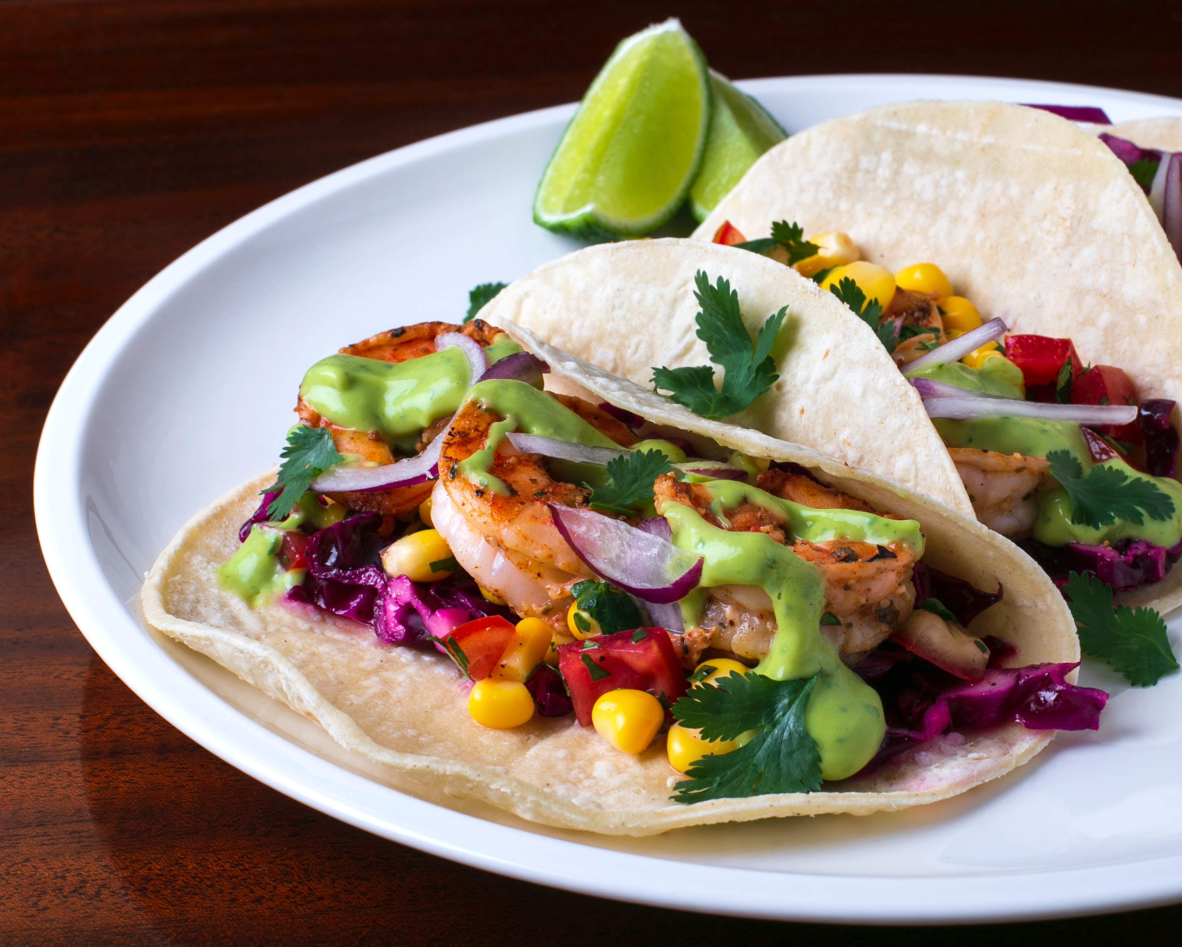
Taco Fundraiser
From February 15th until March 15th, when you order from 74co5.com, Maple Lane Elementary PAC will receive 15% of proceeds! 74CO5 is an authentic Mexican delights company founded in Steveston. They offer a variety of tacos and Mexican cuisine delivered to your door.
They are prepared without preservatives, come fully cooked and are ready to be reheated in just 15 minutes for you to eat. Thank you for supporting our fundraiser!
Upcoming PAC Meeting: Tuesday, April 5th at 6:00 pm Virtually on Teams
IMPORTANT DATES and UPCOMING EVENTS
March 13th- Daylight Savings Time
March 28 – First Day Back
April 2- Ramadan Begins
April 5th- PAC Meeting
April 8th- Class Photos
April 15th- Good Friday (No School)
April 18th- Easter Monday (No School)
April 22nd- Talent Show
April 28th- Grade 6/7 to Camp Jubilee (7:00 a.m.-6:00 p.m.)

