Maple Lane Elementary School
SCHOOL DISTRICT No. 38 (RICHMOND)
7671 Alouette Drive, Richmond, BC V7A 4P2
Tel: (604) 668-6692 Fax: (604) 668-6694
Website: https://maplelane.sd38.bc.ca/

Mrs. L Schwartz

Principal

The Week Ahead: February 21st - February 25th, 2022
Monday: Family Day- No School
Tuesday: Book Fair
Early Dismissal @ 1:45 p.m. for Parent Teacher Conferences
Wednesday: Book Fair
Pink Shirt Day
Early Dismissal @ 1:45 p.m. for Parent Teacher Conferences
Thursday: Book Fair
Friday: Book Fair
Evacuation Drill

Scholastic Book Fair
The Maple Lane Library is hosting an in-person (for students only) and virtual Scholastic Book Fair from
February 22nd- February 25th, 2022. Students will get to visit the Scholastic book fair during their library blocks and make purchases in-person as well.
The Virtual Book Fair is a fantastic way to continue to give our students access to the books they want to read. We’re excited that you will be able to shop together, selecting the books that inspire your readers, from the comfort of home.
Visit our school’s Virtual Book Fair using this link:
https://virtualbookfairs.scholastic.ca/pages/5158600
School Safety Procedures – “hold and secure” and “lockdown” drills
Maple Lane Elementary school, along with the rest of the Richmond School District, is committed to promoting Safe Schools for all students and staff. Part of that commitment is ensuring staff and students are trained and prepared to respond to any threat, minor or serious, to our school population.
Just as we practice safe procedures in case of earthquake (Drop,Cover, Hold) or fire (Evacuation), we will now prepare for other situations that might happen in our neighbourhood (such as a broken gas line) or within our school (such as an intruder). These situations would lead us to “lockdown” the school. For the broken gas line example, we would follow Hold & Secure (Yellow) procedures – a perimeter lockdown. For an intruder, we would follow Code Red procedures - a full lockdown. These procedures have been developed with the support of law enforcement agencies and are consistent through all metro school districts.
We will have a “hold and secure” and “lockdown drill” on March 1st to simulate effective responses to potential safety threats.
Immunization Clinics
Over Spring Break, Immunization Clinics will be held at Richmond Public Health (8100 Granville Avenue). This is for any students who may need immunization catch-up or who prefer to have their immunizations done outside of the school setting. Pleaser call 604-233-3176 to book an appointment.
PAC News
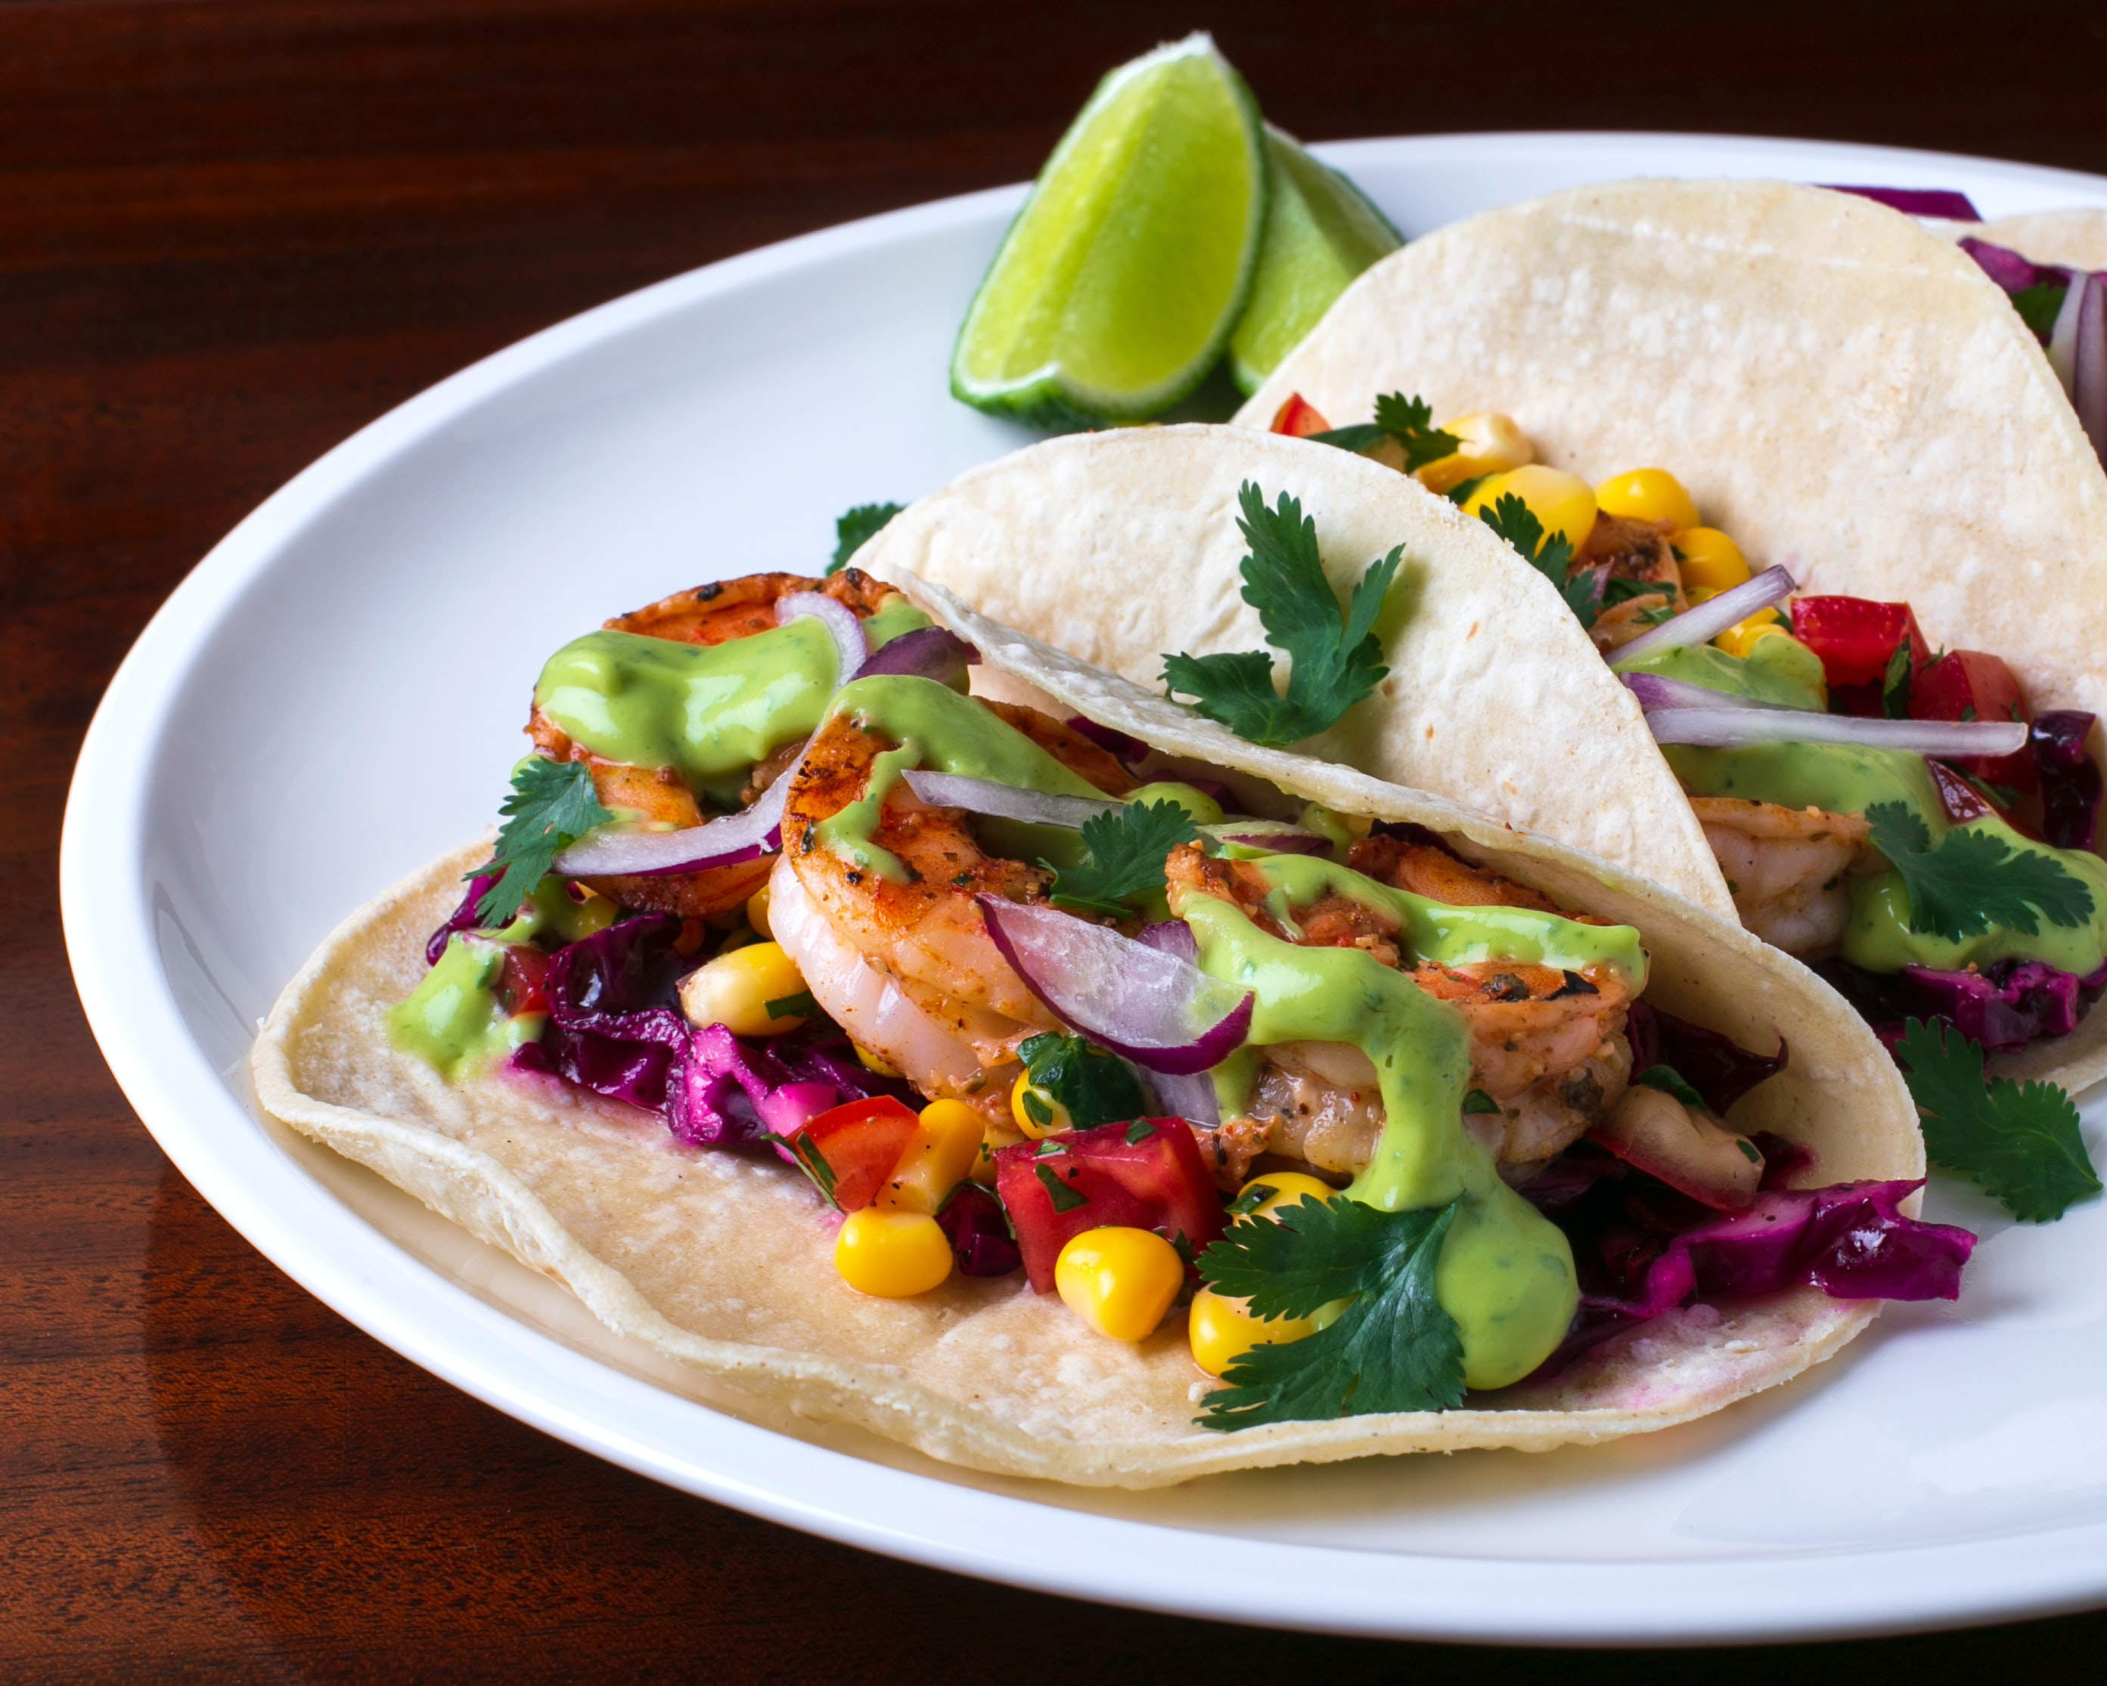
Taco Fundraiser
From February 15th until March 15th, when you order from 74co5.com, Maple Lane Elementary PAC will receive 15% of proceeds! 74CO5 is an authentic Mexican delights company founded in Steveston. They offer a variety of tacos and Mexican cuisine delivered to your door.
They are prepared without preservatives, come fully cooked and are ready to be reheated in just 15 minutes for you to eat. Thank you for supporting our fundraiser!
IMPORTANT DATES and UPCOMING EVENTS
February 28th- 100 Day of School for Div. 8, 9 and 10
March 1st- Lockdown and Hold and Secure Drill
March 1st- Deadline for March Hot Lunch order
March 3rd and 4th- Metis Storytelling and Wood Carving- Whole School Experience
March 4th- Hot Lunch Pizza Day
March 7-11- Spirit Week- stay tuned for more details
March 8th- March PAC Meeting
March 9th – Option B posted to MyEd Parent Portal
March 11th – Last Day before Spring Break
March 15 - March 24 – Spring Break
March 28 – First Day Back

