

SCHOOL DISTRICT NO. 38 (RICHMOND)

MAPLE LANE ELEMENTARY SCHOOL

7671 Alouette Drive, Richmond, BC V7A 4P2
Phone: (604) 668-6692. Fax: (604) 668-6694
Mrs. L. Schwartz, Principal

MAPLE LANE Community
The Week Ahead: November 15th – November 19th, 2021

Monday:

Tuesday:

Wednesday:

Thursday:

Friday:

- Report Cards
For students in Division 7 and 10, report cards will be sent home on Wednesday, December 16th. Other Divisions are part of our Communicating Student Learning Innovation Grant and teacher feedback and assessment will be posted directly to students e-portfolios. Divisions 1-6, 8 and 9 in will receive a Mid-Year Summary of Progress report in early February. If you have any questions, please contact your child’s teacher and or call the school office.
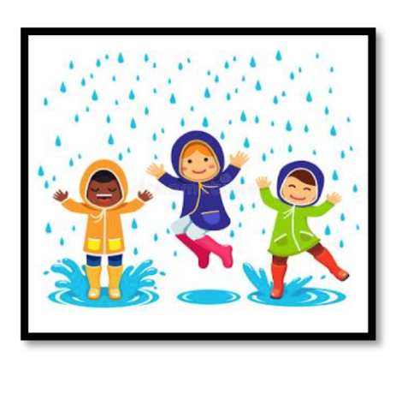
- Dressing for the Weather
The wet weather is here and as we transition into the winter months, we can expect to have more rainy and cold days. A reminder that students go outside rain or shine. Please help us by sending your child to school with weather appropriate clothing such as warm, water-resistant coats and boots. Students may also benefit by bringing a change of clothing to keep at school.

- Winter Concert
Our staff is currently in the process on making plans for our winter concert. Stay tuned for more information!

- Kindergarten Registration
Richmond School District 38 is excited to welcome kindergarten registration applications for children born in 2017, turning 5 in 2022. These children will begin kindergarten in September 2022. Online registration opened on November 1, 2021. Please visit our website http://www.sd38.bc.ca/kindergarten for more information about our online registration process, required documents, important dates and FAQs.
Families are encouraged to register any time during the Priority 1 registration period (November – January) for the best chance at attending their catchment school. All registration applications completed any time during the Priority 1 registration period will receive placement decisions via emails from the school by February 4, 2022.
Instead of in person information evenings this year, we have posted short videos that provide our new parents with information about the registration process, English Language Learner (ELL) assessments, and District Program Options – Early French Immersion and Montessori. These videos are available in English and Mandarin. Please view the videos at
http:// www.sd38.bc.ca/kindergarten.
Finally, there will be a Kindergarten Information Evening for parents of students with disabilities and diverse abilities
via Zoom on November 17 from 6:30 – 7:30 p.m. A link to the Zoom meeting will be posted on the Kindergarten Registration website closer to the meeting date http://www.sd38.bc.ca/kindergarten
- PAC NEWS

Save the Date
The Maple Lane PAC invite you to join us for Winter Wonderland Family Skate Fundraiser at Minoru Arenas. Saturday, December 11th, 2021, 4:30-6:00 p.m. Please see the attached poster.

Purdy’s Fundraiser

Support our school this holiday season by purchasing treats from our Maple Lane PAC Purdy's chocolate fundraiser. 25% of all proceeds will go directly to our school!
Please see the attached ordering instructions. Chocolate will be available for pick up on Friday, December 10th from 2:30-3:30.

Next PAC Meeting - Tuesday, December 7th at 6:00 p.m.
A meeting link along with an agenda and previous months minutes will be shared closer to the date.


Upcoming Dates
November 22nd- Professional Development Day- Students Do Not Attend
November 23rd- How Raven Stole the Sun Performance
9:00 a.m.-Div. 6-10 and 10:00 a.m.- Div. 1-5
November 30th- Grade 6 and 7 Immunizations
December 1st- Kindergarten Hearing Screening

Have a wonderful weekend,

Mrs. Lisa Schwartz

